FTK Imager:
Create Disk Image after Deleting a Picture

Course Name: FRS301-Digital Forensics
Student Name: Nguyễn Trần Vinh – SE160258
Instructor Name: Lê Tiến Dũng
Lab Due Date: 7/2/2023

Section 0. Background Information
- What is FTK Imager?
  - The FTK toolkit includes a standalone disk imaging program called FTK Imager. The FTK Imager has the ability to save an image of a hard disk in one file or in segments that may be later reconstructed.
  - It calculates MD5 hash values and confirms the integrity of the data before closing the files.
  - In addition to the FTK Imager tool can mount devices (e.g., drives) and recover deleted files.
- Pre-Requisite
  - Install FTK Imager
  - Create Virtual Hard Drive, Delete File, Recover File
    - Note: This lab is necessary, because you will need to create a Virtual Hard Drive.
- Lab Notes
  - In this lab we will do the following:
    - Download a Picture to the Virtual Hard Drive
    - Delete a Picture from the Virtual Hard Drive
    - Delete the Picture from the Recycle Bin
    - Create an image of the Virtual Hard Drive with FTK Imager

Section 1: Log into WXP-SP2
- Start VMware Player
  - Instructions
    - For Windows 7
      - Click Start Button
      - Search for "vmware player"
      - Click VMware Player
    - For Windows XP
      - Starts --> Programs --> VMware Player

- Start Up WXP-SP2.
  - Instructions:
    - Click on WXP-SP2
    - Click on Edit virtual machine Settings
  - Note(FYI):
    - For those of you not part of my class, this is a Windows XP machine running SP2.

- Edit Virtual Machine Settings
  - Instructions:
    - Click on Network Adapter
    - Click on the Bridged Radio button
    - Click on the OK Button
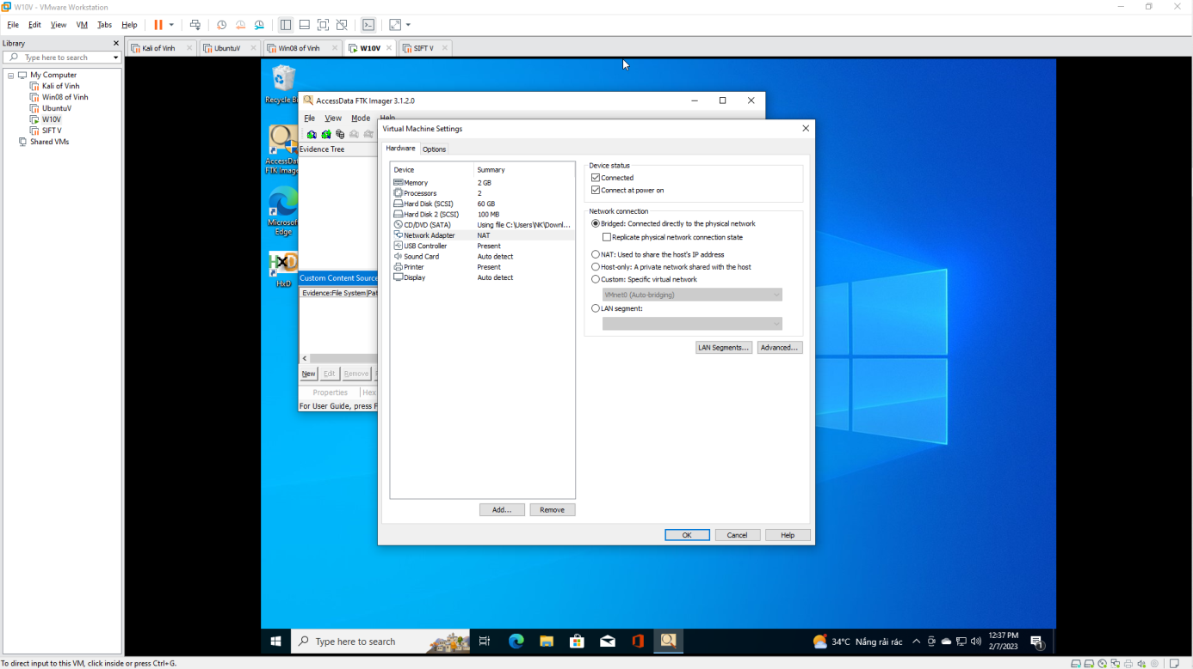

- Play Virtual Machine
  - Instructions:
    - Click on WXP-SP2
    - Click on Play virtual machine

- Logging into WXP-SP2.
  - Instructions:
    - Click on Administrator
    - Password: Supply Password
    - Press <Enter> or Click the Arrow

- Open a Command Prompt
  - Instructions:
    - Start --> All Programs --> Accessories --> Command Prompt

- Obtain WXP-SP2's IP Address
  - Instructions:
    - ipconfig
  - Note(FYI):
    - In my case, WXP-SP2's IP Address 192.168.1.116.
    - This is the IP Address of the Victim Machine that will be attacked by Metasploit.
    - Record your WXP-SP2's IP Address.
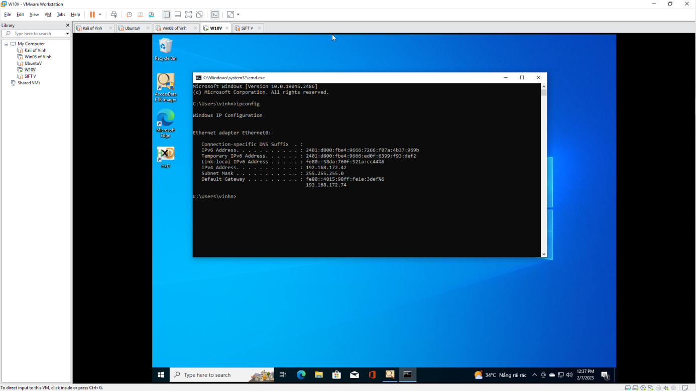.

Section 2: Download Test Picture
- Start Firefox
  - Instructions:
    - Click the Start Button
    - All Programs --> Mozilla Firefox

- Start Test Picture Download
  - Instructions:
    - Place the following URL in the Firefox Address Textbox
      - http://www.computersecuritystudent.com/FORENSICS/FTK/IMAGER/FTK_IMG_313/lesson3/whistle.jpg
    - Right Click on the image
    - Click on "Save Image As..."
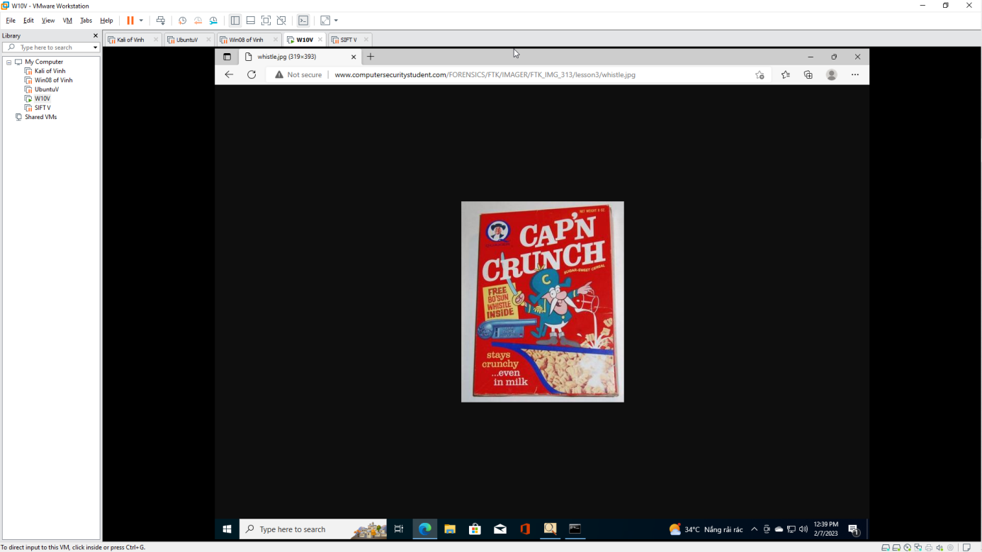

- Save Test Picture Download
  - Instructions:
    - Save in: Select the FTK (Z:) Drive
    - Filename: whistle
    - Save as type: JPEG Image
    - Click the Save Button

- Open My Computer
  - Instructions:
    - Click the Start Button
    - All Programs --> My Computer

- Open your FTK(Z:) Drive
  - Instructions:
    - Navigate to your FTK(Z:) Drive

- Delete the Test Image
  - Instructions:
    - Right Click on whistle.jpg
    - Click Delete
    - Click the OK Button in the "Confirm Deletion" warning window.


- Open the Recycle Bin
  - Instructions:
    - Double Click on the Recycle Bin
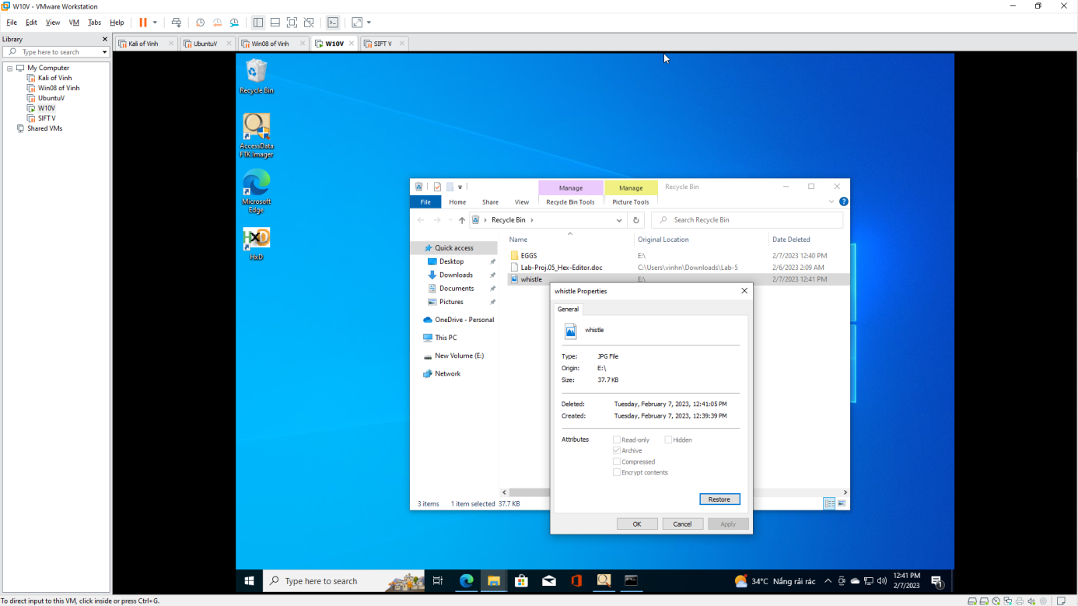

- Delete Test Picture From the Recycle Bin
  - Instructions:
    - Right Click on whistle.jpg
    - Click Delete
    - Confirm File Delete Windows: Click the Yes Button.
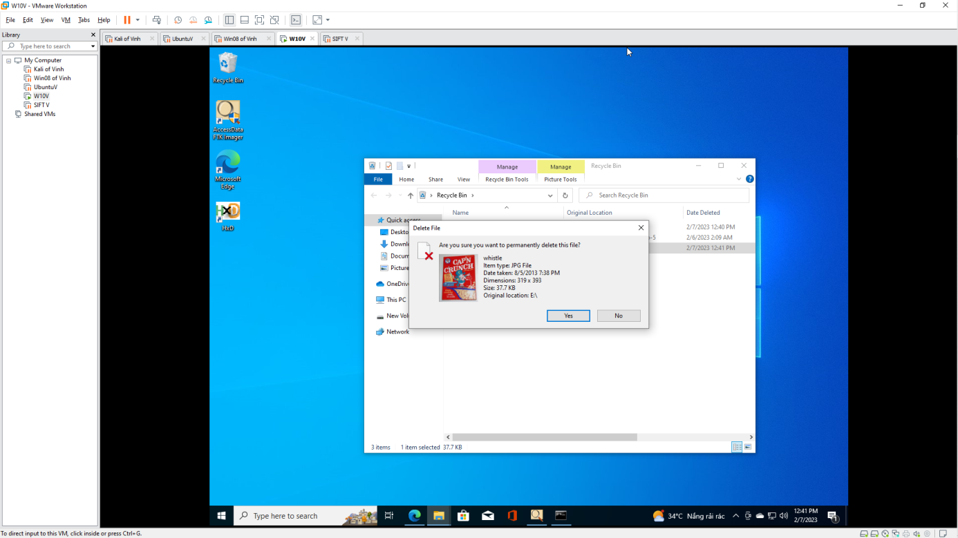
Section 3: Forensics Directory
- Open a Command Prompt
  - Instructions:
    - Start --> All Programs --> Accessories --> Command Prompt

- Create a Forensics Directory
  - Instructions:
    - mkdir C:\FORENSICS
    - dir C:\FORENSICS
  - Note(FYI):
    - If you completed the previously lab you will receive an error that states "A subdirectory or file C:\FORENSICS already exists."
    - In Addition, the directory listing might list remnant files (eg., horse.jpg) from the previous lab.
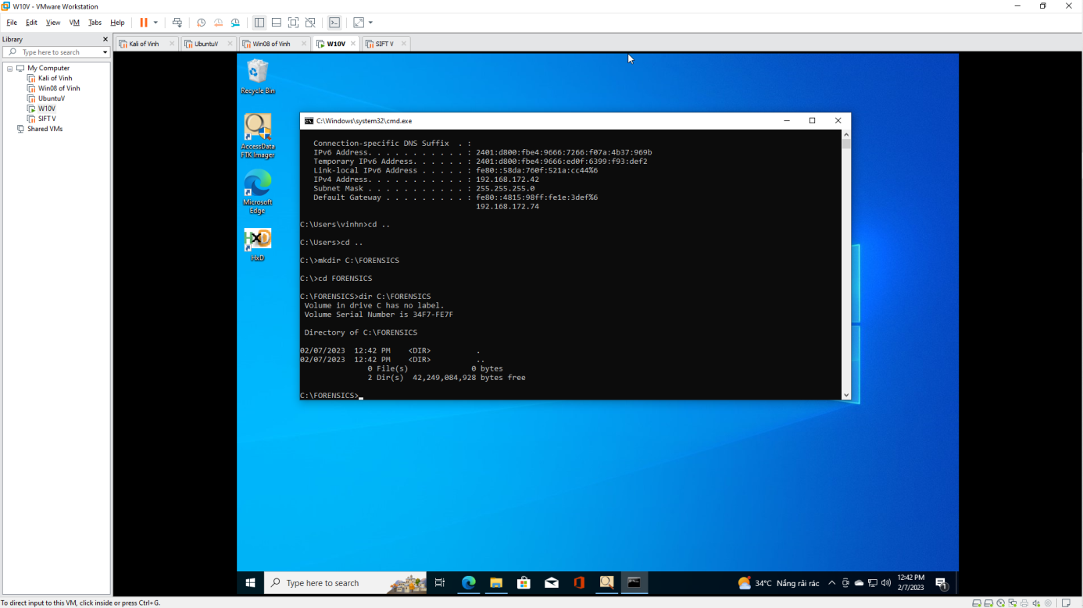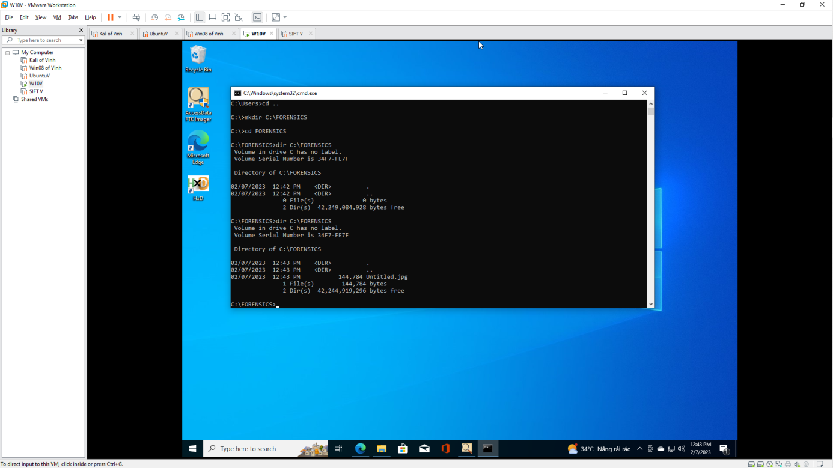

Section 4: Start FTK Imager
- Start FTK Imager
  - Instructions:
    - Click on the Start Button
    - All Programs --> AccessData --> FTK Imager --> FTK Imager
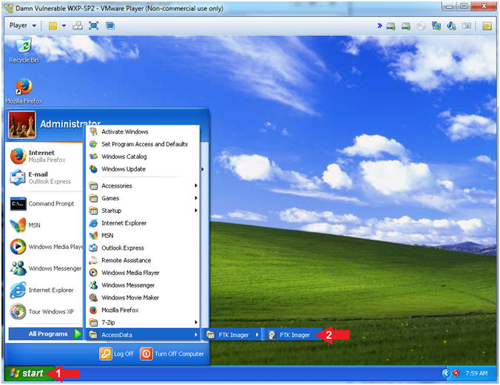

Section 5: FTK Imager: Create Disk Image…
- Add Evidence
  - Instructions:
    - File --> Create Desk Image...
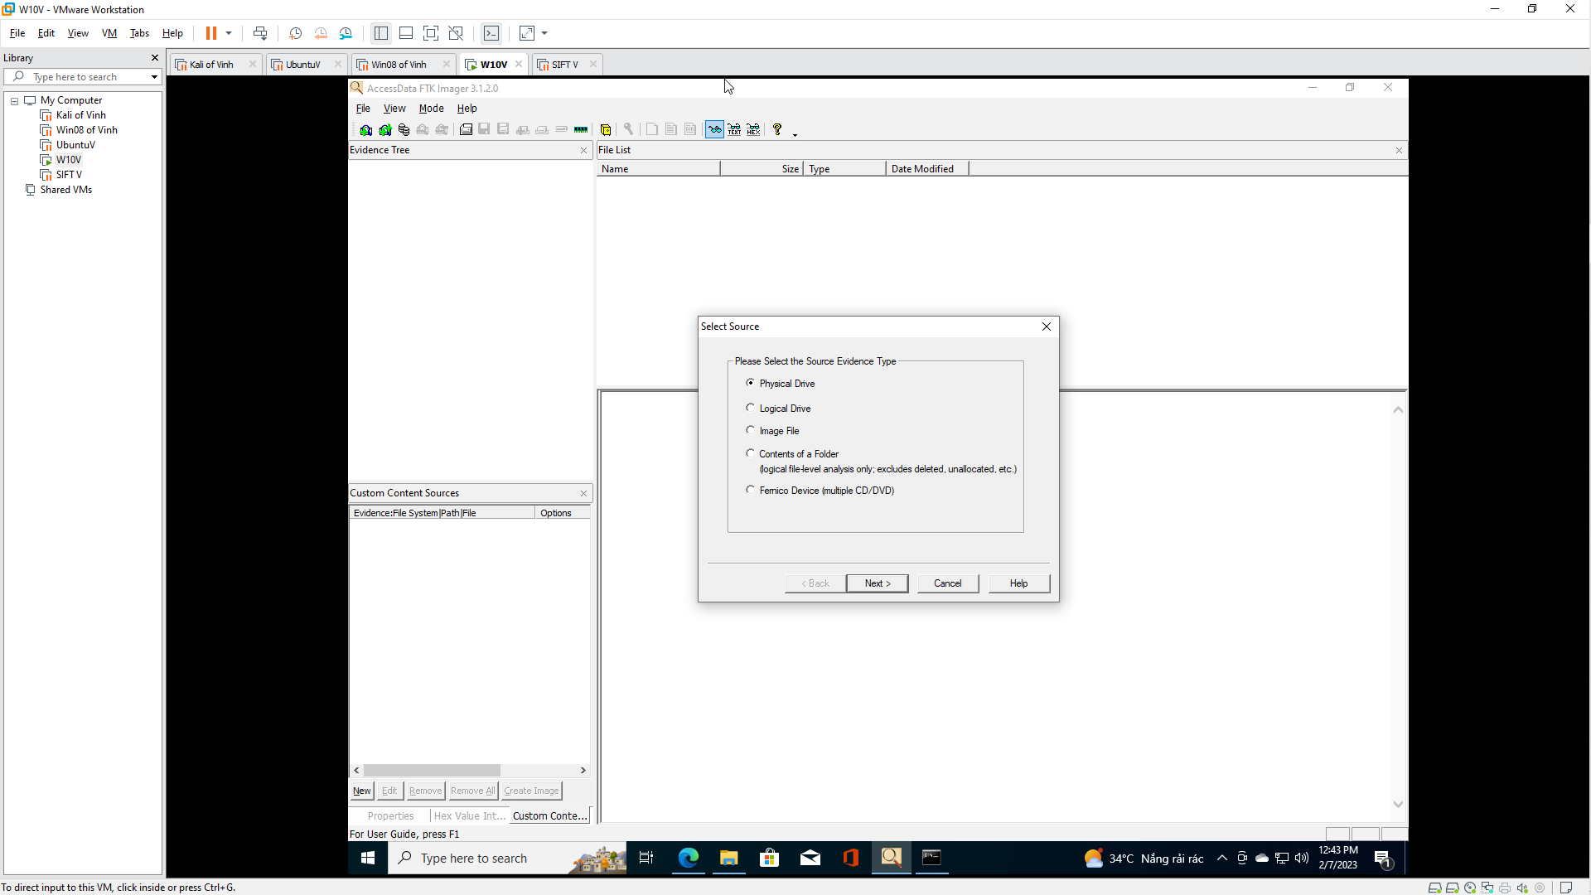

- Select Source
  - Instructions:
    - Select the "Physical Drive" Radio Button
    - Click the Next Button
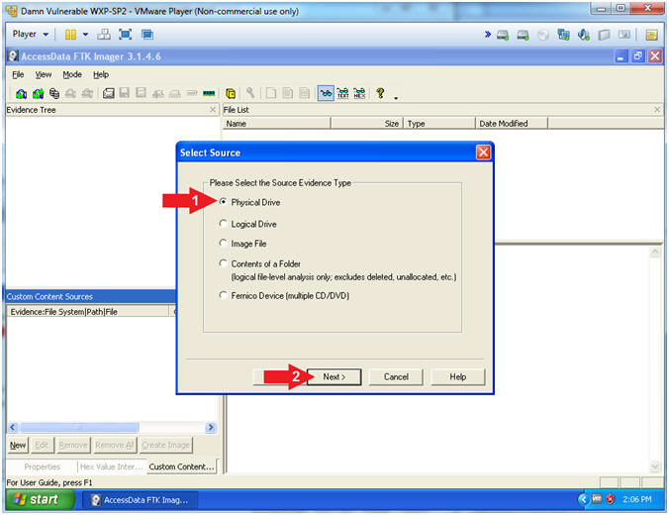

- Select Drive
  - Instructions:
    - Select \\PHYSICAL DRIVE1 ... (106MB SCSI)
    - Click the Finish Button
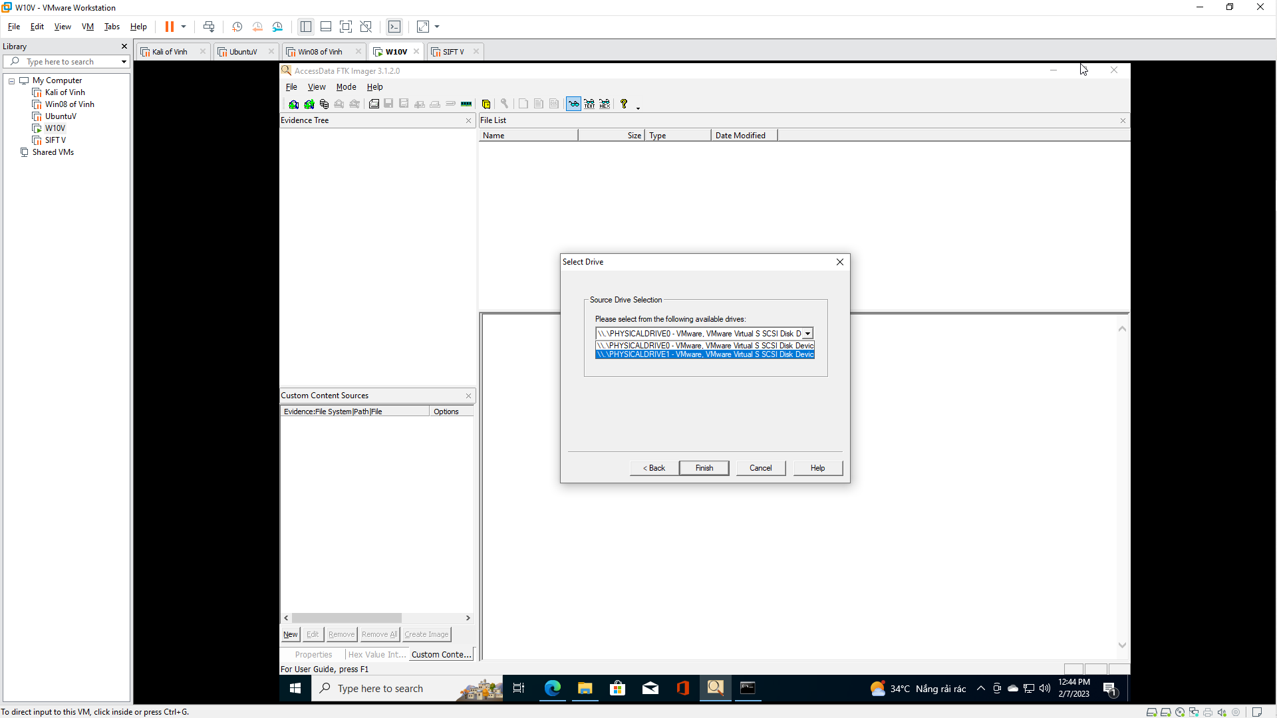

- Create Image
  - Instructions:
    - Check the "Verify images after they are created" checkbox
    - Click the Add... Button
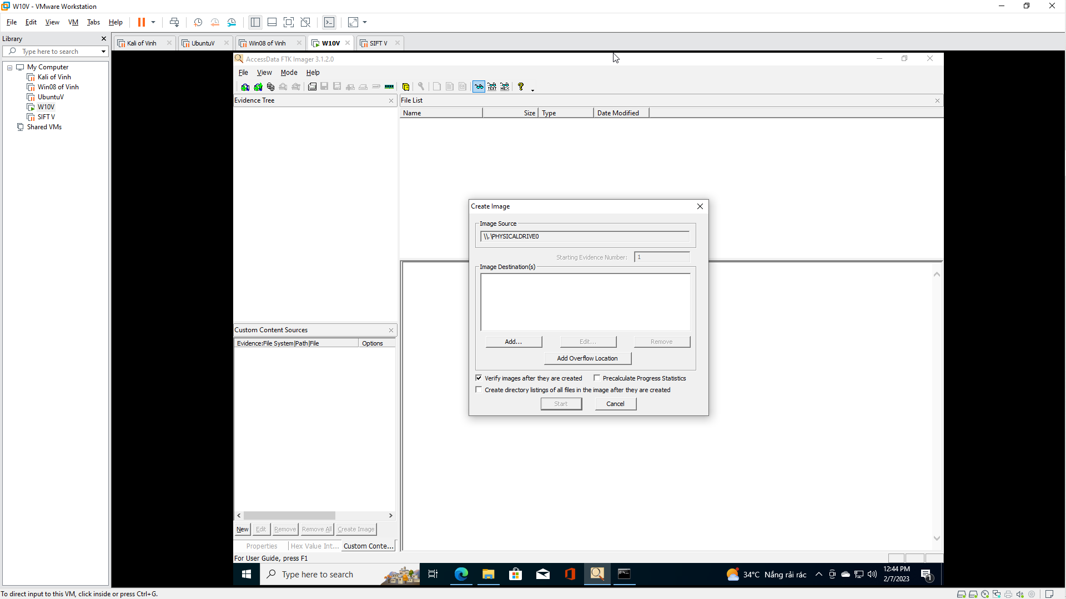

- Select Image Type
  - Instructions:
    - Select the Raw(dd) Radio Button
    - Click the Next Button
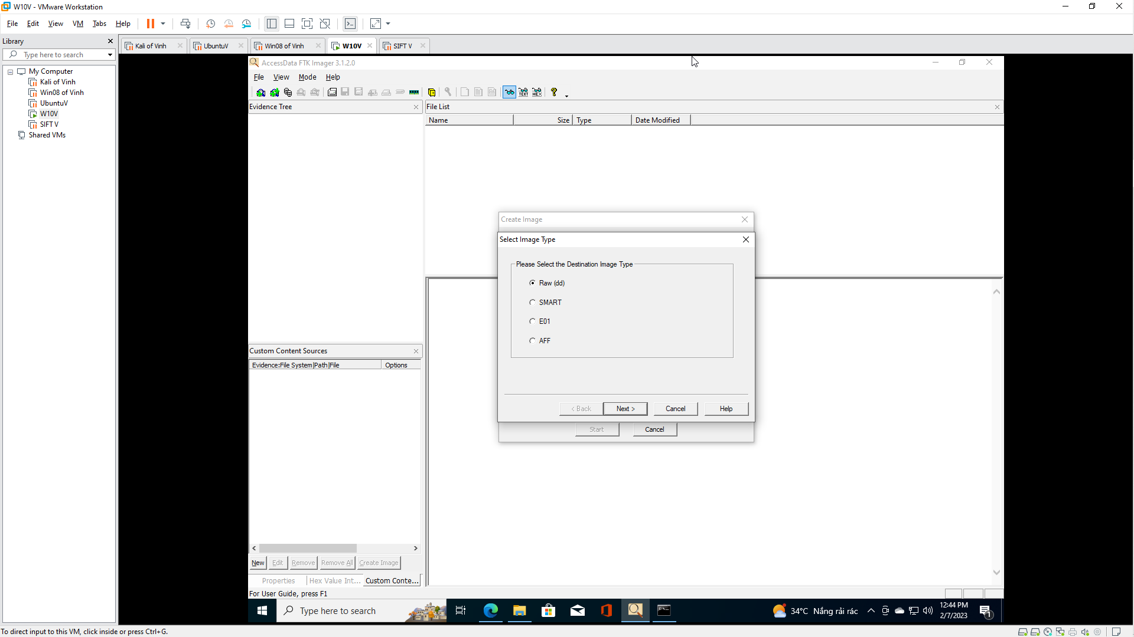

- Evidence Item Information
  - Instructions:
    - Case Number: 00001
    - Evidence Number: 001
    - Unique Description: Practice Image
    - Examiner: Your Name
      - For Proof of Lab purposes, replace the string "Your Name" with your actual name.
    - Contains a delete Captain Crunch Whistle
    - Click the Next Button

- Select Image Destination
  - Instructions:
    - Image Destination Folder: C:\FORENSICS
    - Image Filename (Excluding Extension): practice-01
    - Image Fragment Size(MB): 1500
    - Click the Finish Button
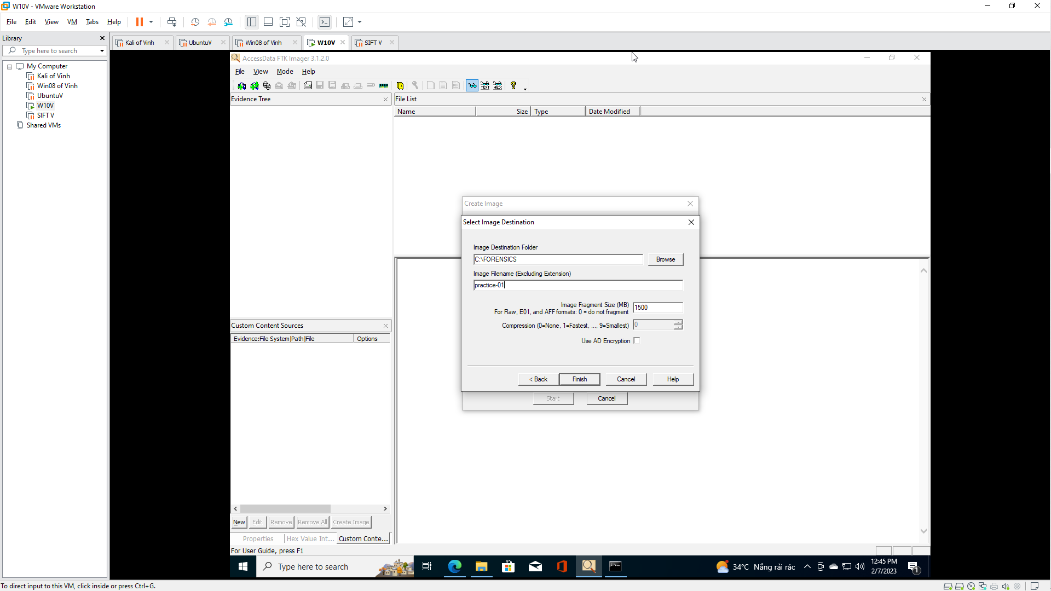

- Create Image
  - Instructions:
    - Check "Verify images after they are created"
    - Click the Start Button
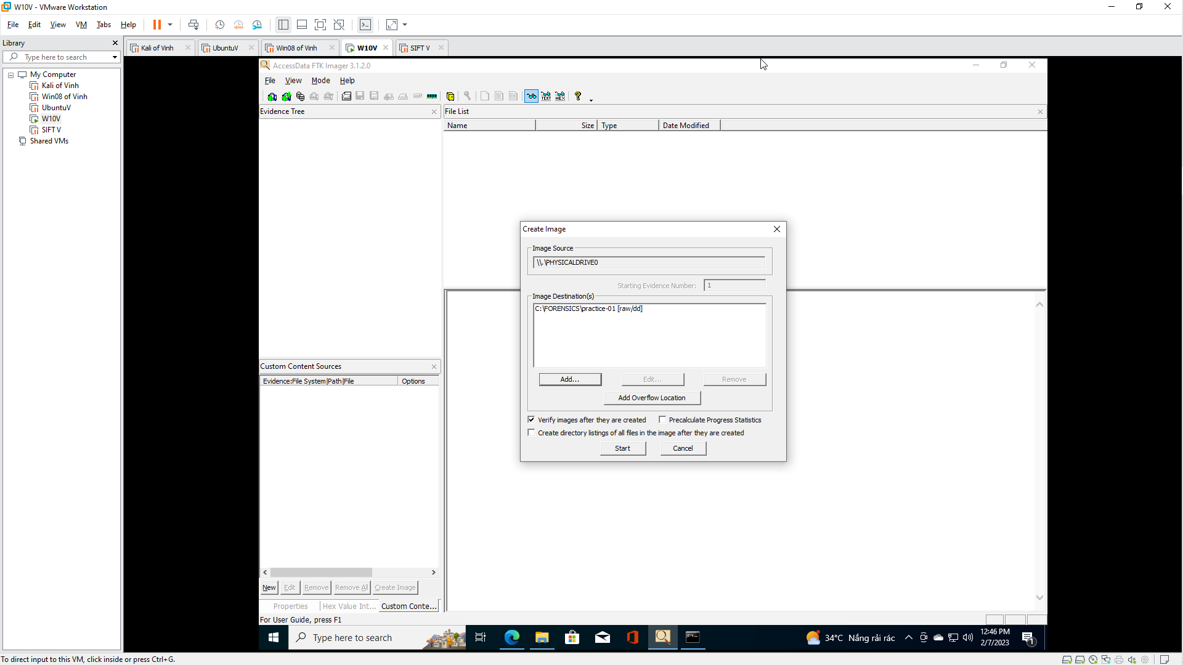

- Drive/Image Verify Results
  - Instructions:
    - View MD5 Matching Hashes
    - View MD5 Matching Hashes
    - Click the Close Button
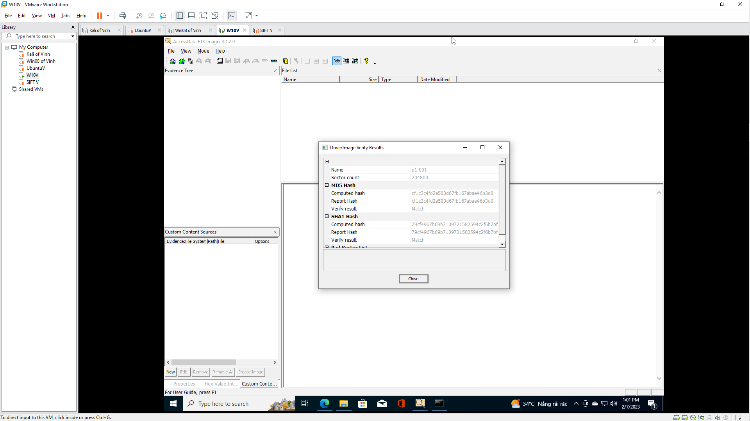

- Image created successfully
  - Instructions:
    - Click the Close Button

Section 6: Proof of Lab
- Proof of Lab
  - Instructions:
    - cd C:\FORENSICS
    - dir | findstr "practice"
    - type practice-01.001.txt | findstr "Examiner"
    - date /t
    - echo "Your Name"
      - This should be your actual name.
      - e.g., echo "John Gray"
  - Proof of Lab Instructions
    - Press both the <Ctrl> and <Alt> keys at the same time.
    - Do a <PrtScn>
    - Paste into a word document
    - Upload to Moodle
